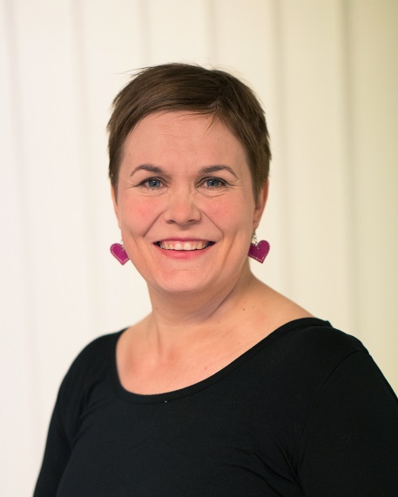 | Mirka Vainikka  Mirka Vainikka works as Executive Director of Finnish prevention NGO “Free from Drugs”. NGO is one of the oldest drug work specific NGO in Finland that was founded in 1984 by the parents of people living with drug use disorders with the aim to support those affected by drug use.  Ms. Vainikka has background in social work and has worked during her career with different substance abuse services from drop-in services to medication assisted treatment. Before starting her current career, she was the head of a low threshold harm reduction center. She has originally joined Free from Drugs as a volunteer for almost 20 years ago.

